**Nama : Faiz Fadhil Abrar**

**Kelas : Reguler Pagi**

**NIM : 200320013**

1. Joint Table

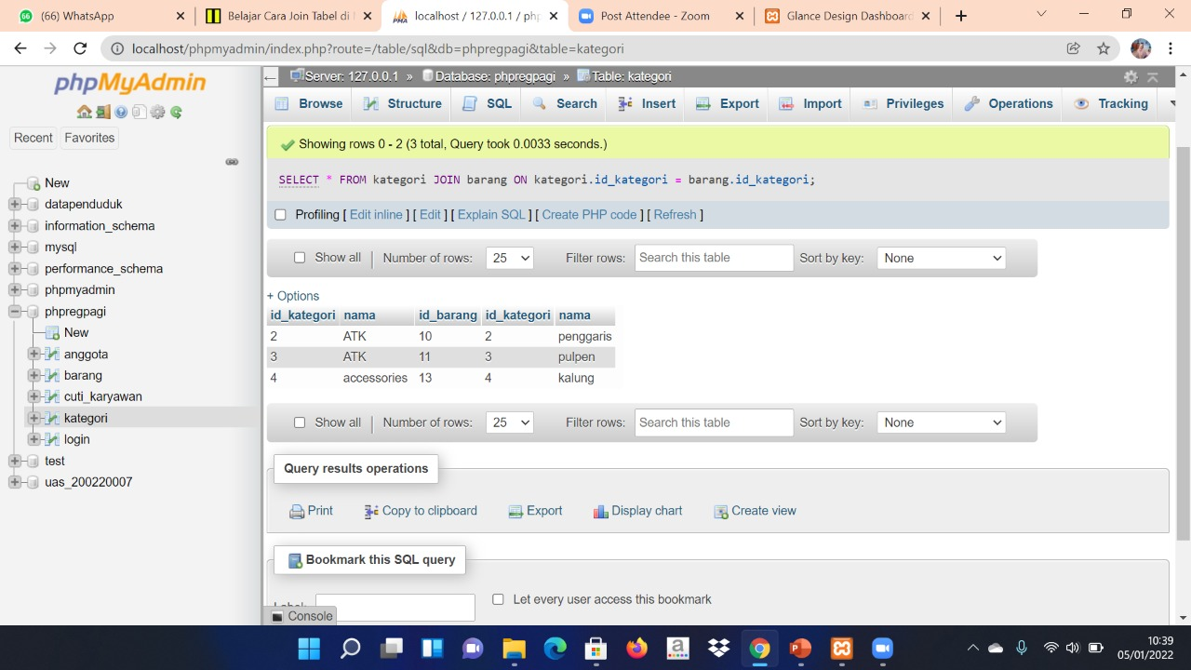

1. Fungsi Count

